***OS Assignment 1***

**Problem 1: Read the instructions carefully and answer accordingly. If there is**

**any need to insert some data then do that as well.**

**a) Navigate and List:**

a. Start by navigating to your home directory and list its contents. Then, move into a

directory named "LinuxAssignment" if it exists; otherwise, create it.

1. Use **cd** command , this redirects to home directory
2. Use **ls** command to list all the directories present in the home directory
3. As LinuxAssignment directory is not present , so we created it using : **mkdir LinuxAssignment**
4. Use **cd** command to go into the newly created directory .

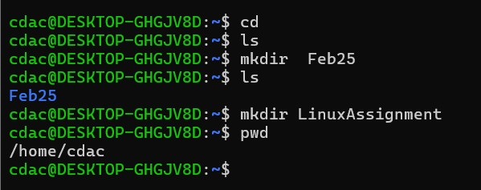

**b) File Management:**

a. Inside the "LinuxAssignment" directory, create a new file named "file1.txt". Display its

contents.

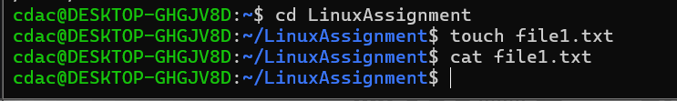

Ans =>

1. Use **cd LinuxAssignmentto** move in the directory
2. Use **touch** command to crate a file
3. Use **cat** command to view the content

**c) Directory Management:**

a. Create a new directory named "docs" inside the "LinuxAssignment" directory.

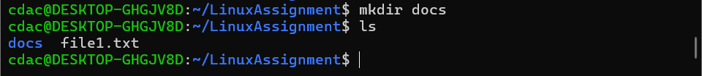

Ans = >

1. make directory named docs by using **mkdir** command
2. use **ls** command to see the generated directory

**d) Copy and Move Files:**

a. Copy the "file1.txt" file into the "docs" directory and rename it to "file2.txt".

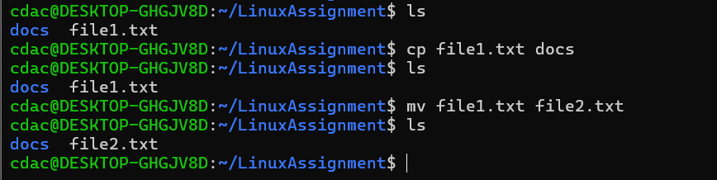

Ans = >

1. Use **cp** command to copy the file file1.txt to another directory .
2. After the file is copied into another directory , use **mv** command to move and rename the file to docs directory

**e) Permissions and Ownership:**

a. Change the permissions of "file2.txt" to allow read, write, and execute permissions for

the owner and only read permissions for others. Then, change the owner of "file2.txt" to

the current user.

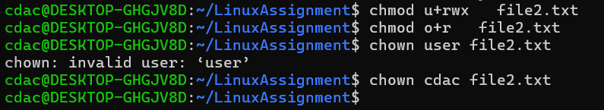

Ans = >

1. To change the ownership use command **chmod**
2. **U** for owner ,  **r** for read , **w** for write , **x** for execution , o for others
3. Use of **chown** for ownership

**f) Final Checklist:**

a. Finally, list the contents of the "LinuxAssignment" directory and the root directory to

ensure that all operations were performed correctly .

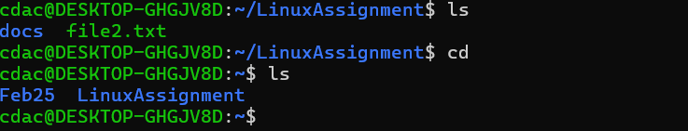

Ans = >

1. Use **ls** command for details before linuxAssignment directory
2. Use **cd** for home directory and do **ls** command for details about home directory

**g) File Searching:**

a. Search for all files with the extension ".txt" in the current directory and its subdirectories.

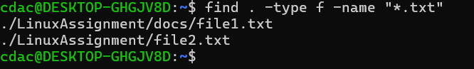

Ans = >

1. Use **find** command to find the file , use **.** for current directory
2. **-type** for restriting the file search to regular files
3. **-name “*.txt”** specifies the filters file in .txt extension
4. . for current directory

**(B)**  Display lines containing a specific word in a file (provide a file name and the specific

word to search).

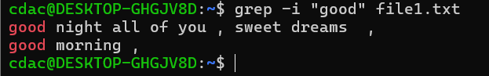

**Ans :**

1. Use **grep** for searching
2. **-I** for Ignore case distinctions while searching.
3. **“good”** word to search
4. File1.txt file in which we are searching

**h. System Information:**

a. Display the current system date and time. 

Ans :

1. Use **date** command to display time and date

**i) Networking:**

a. Display the IP address of the system.

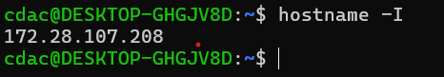

Ans =>

**Hostname :** this command is to display or set the system’s hostname

**-I** : to display ip address

b. Ping a remote server to check connectivity (provide a remote server address to ping).

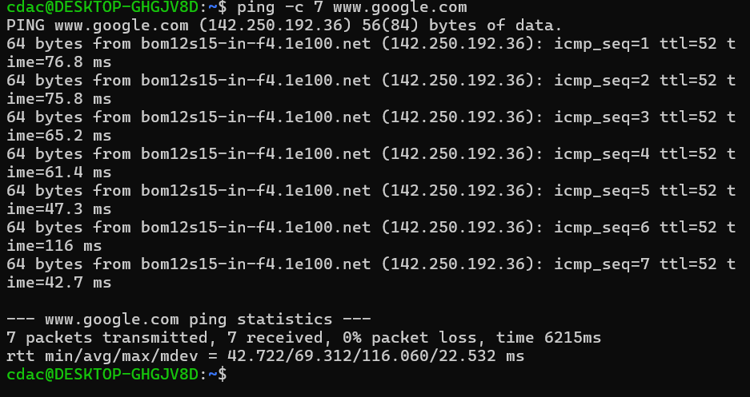

**Ping :** to check connectivity

**-c** : restricting the ping limit

**j) File Compression:**

a. Compress the "docs" directory into a zip file.



Use **tar** command for making zip

**-c** : Create a new archive.

**V**: Verbose mode.

**Z**:Compress the archive with gzip

**F**:Specify the archive file name.

**b. Extract the contents of the zip file into a new directory**

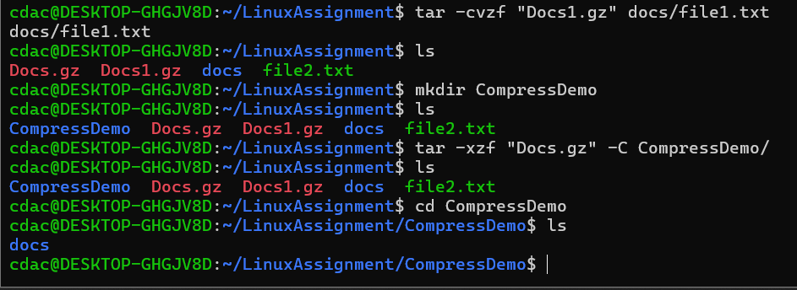

**Ans =>**

1.Use **tar -cvzf “Docs.gz” docs/** command to compress the docs

directory into file “Docs.gz “

2. Use ls command to the display the contents of current

directory.

3. Use **mkdir** new command to create a directory with name

“new”

4. use command tar -xzf “Docs.zip” -C new/ to extract the

contents of Docs.zip into new/ directory.

**k) File Editing:**

**a. Open the "file1.txt" file in a text editor and add some text to it.**

**b. Replace a specific word in the "file1.txt" file with another word (provide the original**

**word and the word to replace it with).**

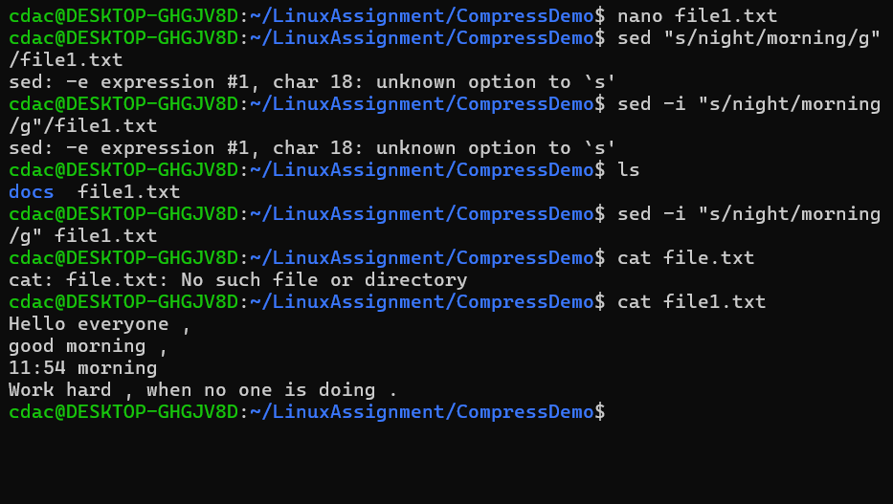

Ans = >

1.Use nano target_file.txt command to open nano editor to

add few contents in it

2. Use the command sed -i "s/Hello/Hi /g" file1.txt to

subs􀆟tute the word Hello with Hi in target file (file1.txt).

3 -i indicates the shell to ignore case distnction, s represents

the substution and g indicates the shell to replace all

occurrences in each line.

**Problem 2: Read the instructions carefully and answer accordingly. If there is**

**any need to insert some data then do that as well**

**a. Suppose you have a file named "data.txt" containing important information. Display the**

**first 10 lines of this file to quickly glance at its contents using a command**.

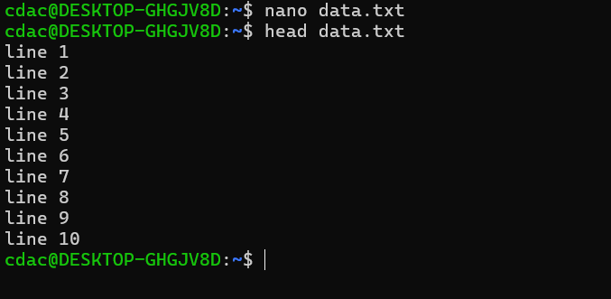

Use head data.txt command to display first 10 lines of file

“data.txt”

**b. Now, to check the end of the file for any recent additions, display the last 5 lines of**

**"data.txt" using another** command**.**

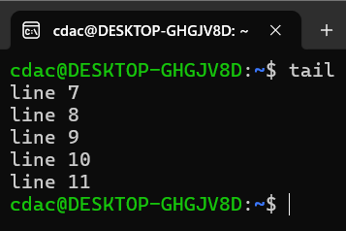

Use tail data.txt command to display last 10 lines of file

“data.txt”

**c. In a file named "numbers.txt," there are a series of numbers. Display the first 15 lines of**

**this file to analyze the initial data set.**

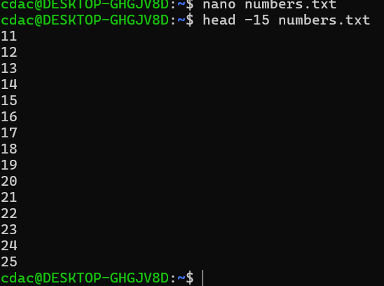

Use nano command to create a file named numbers.txt

Use head -15 numbers.txt command to display first 15 lines

of file “numbers.txt”

**d. To focus on the last few numbers of the dataset, display the last 3 lines of "numbers.txt".**

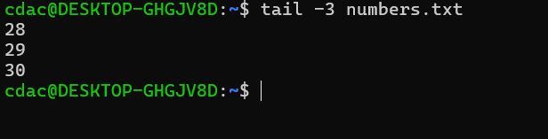

Use head -3 numbers.txt command to display first 3 lines of

file “number.txt”

**e. Imagine you have a file named "input.txt" with text content. Use a command to translate**

**all lowercase letters to uppercase in "input.txt" and save the modified text in a new file**

**named "output.txt."**

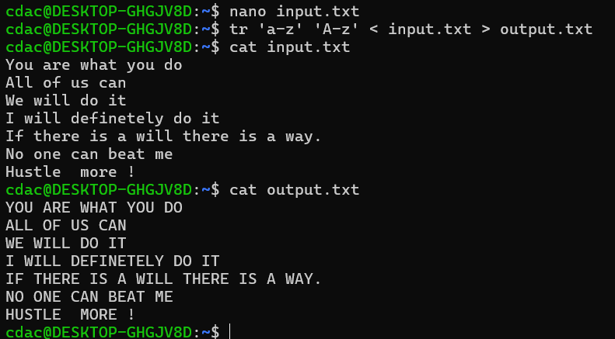

Use nano command to create a file named input.txt

Use **tr ‘a-z’ ‘A-Z’ <input.txt> output.txt** command to convert

the content of input.txt to upper case and store it in new file output.txt.

**f. In a file named "duplicate.txt," there are several lines of text, some of which are**

**duplicates. Use a command to display only the unique lines from "duplicate.txt."**

Use nano command to create a file named duplicate.txt

put some repetitive textual content in it

Use sort duplicate.txt command to sort the contents of duplicate.txt file

use uniq command to uniquely identify .

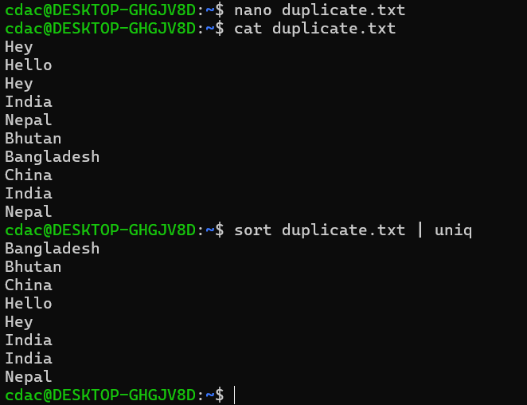

**g. In a file named "fruit.txt," there is a list of fruits, but some fruits are repeated. Use a**

**command to display each unique fruit along with the count of its occurrences in**

**"fruit.txt."**

Create a file named fruit.txt using nano command

Use the command **sort** fruit.txt to sort names of fruit

**| uniq -c**  counts and displays the occurrences of each

unique line.

